**Create VPC using Terraform  
========================**

**1) Create VPC**

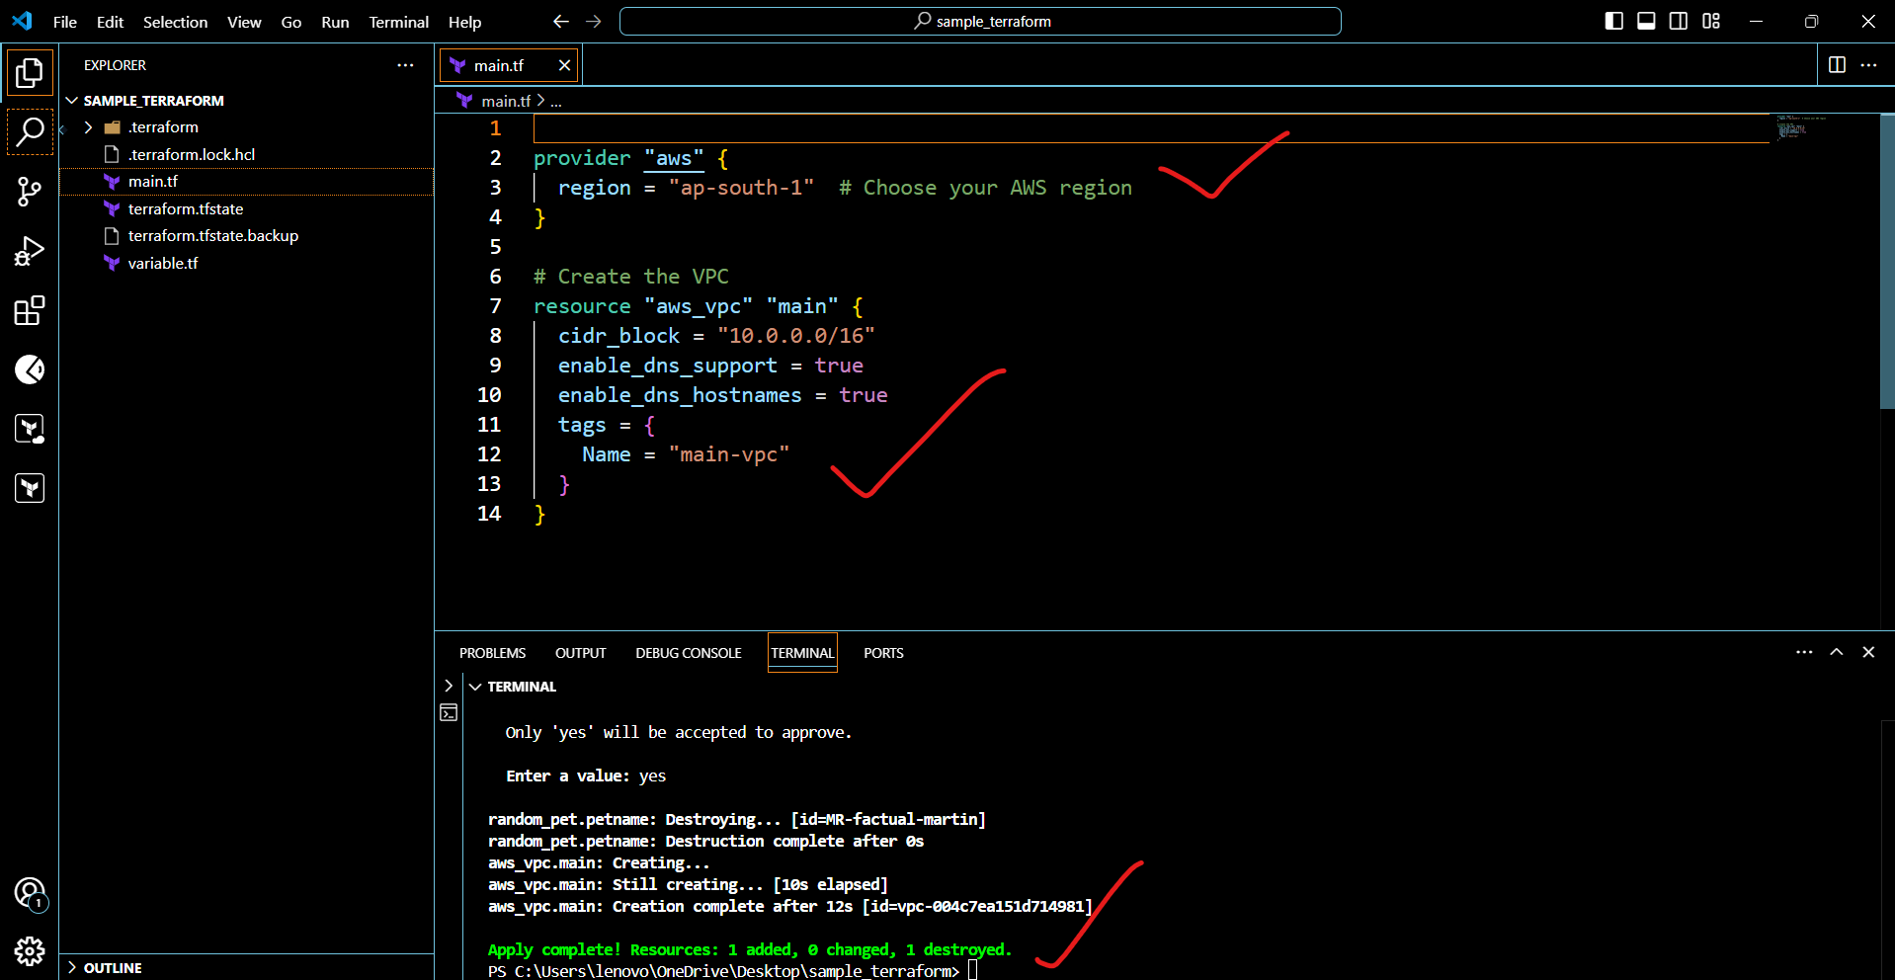

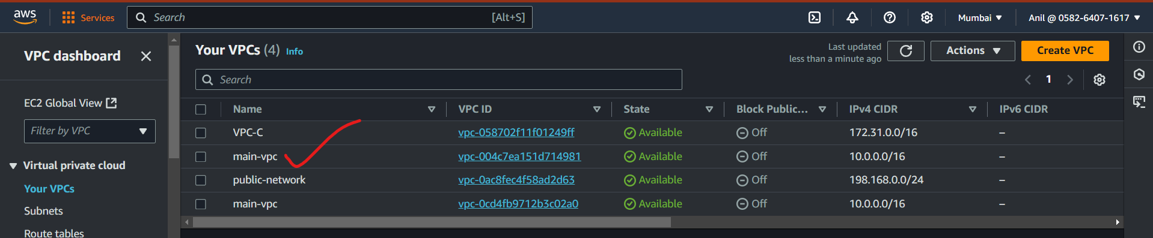

**2) Create Internet gateway**

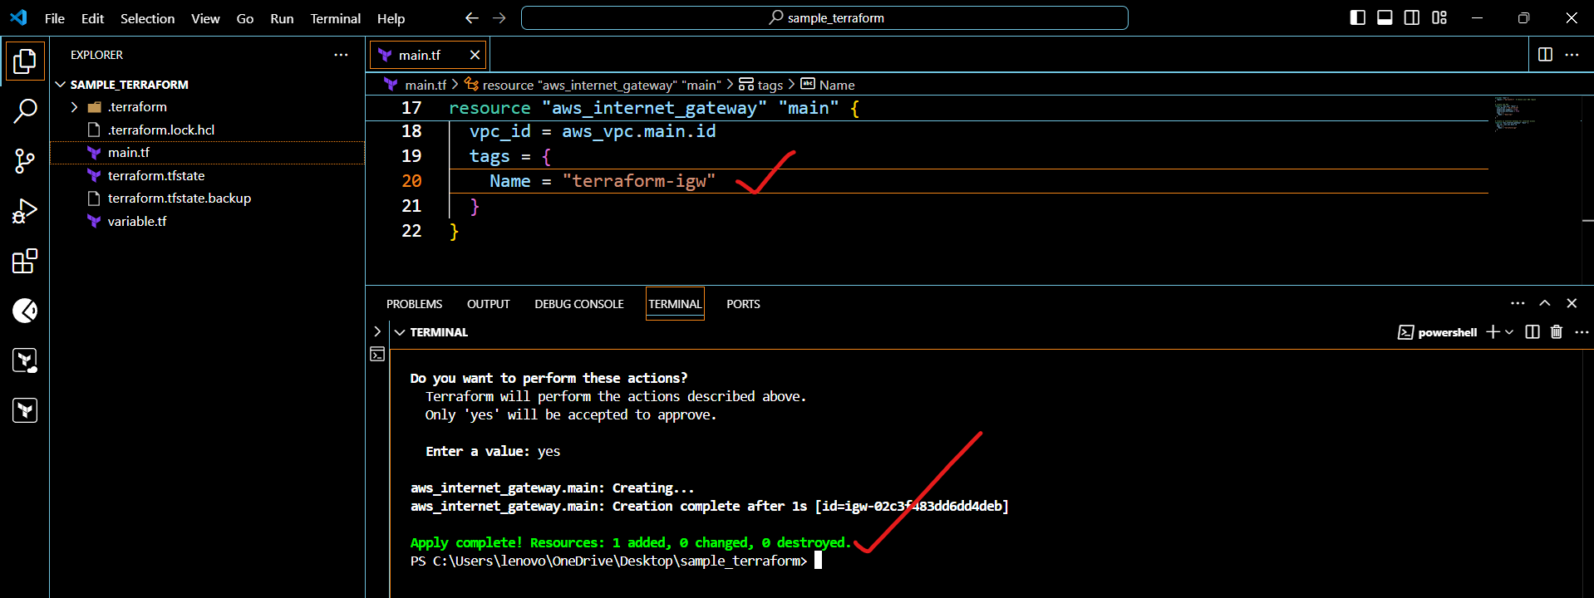

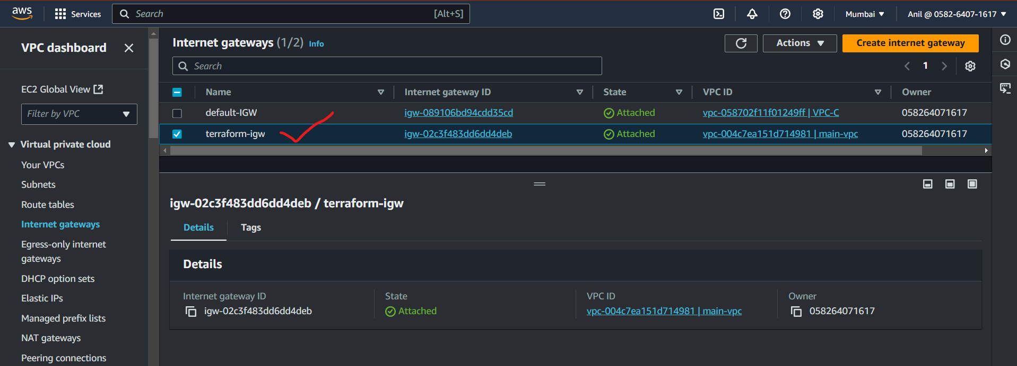

**3) Create Custom Route Table**

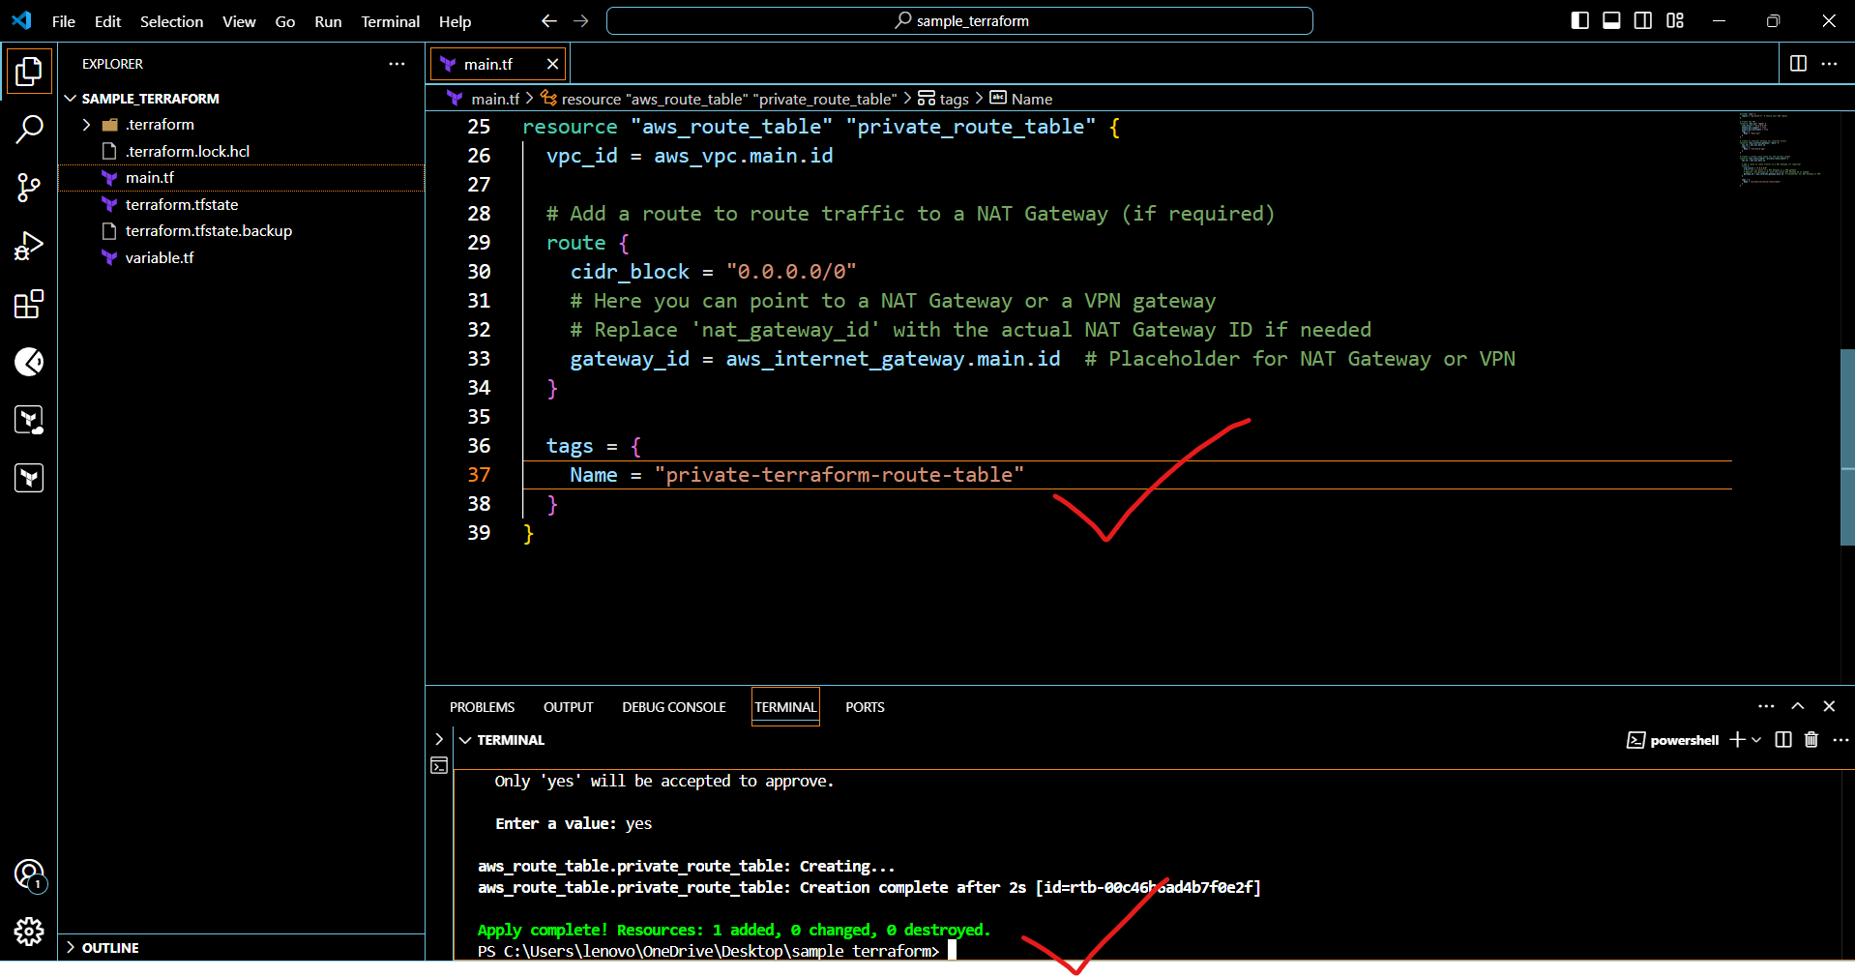

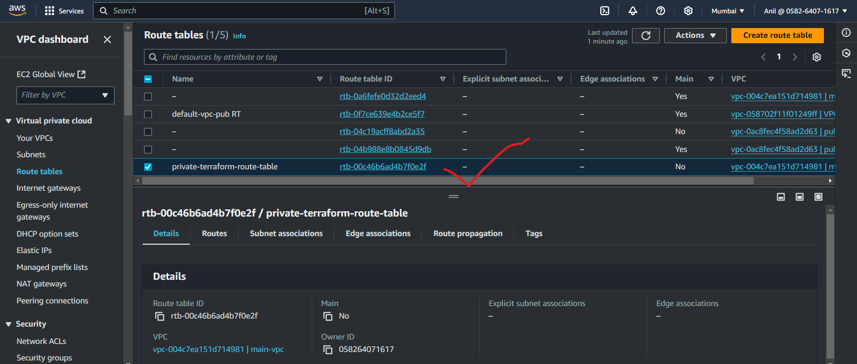

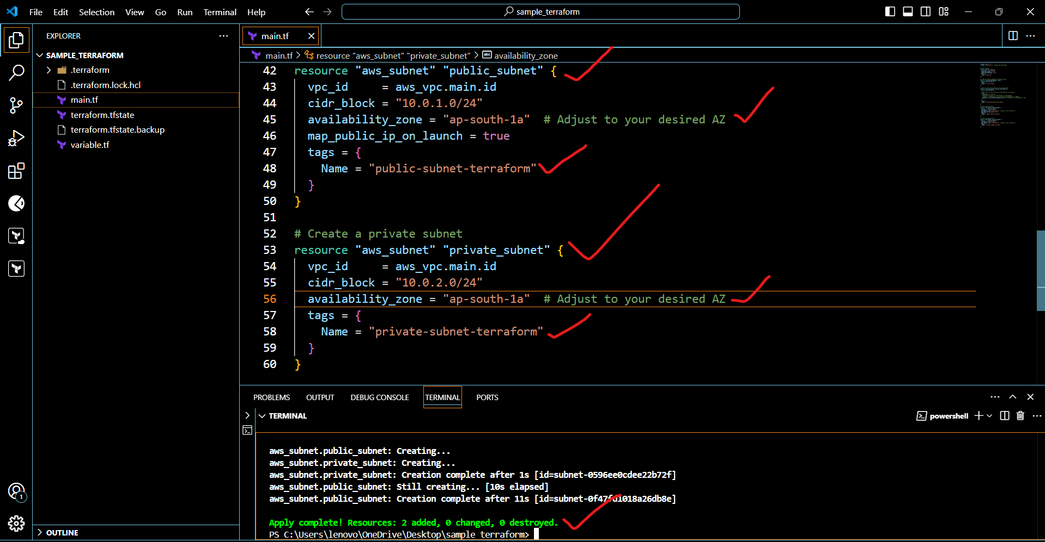

**4) Create Subnet**

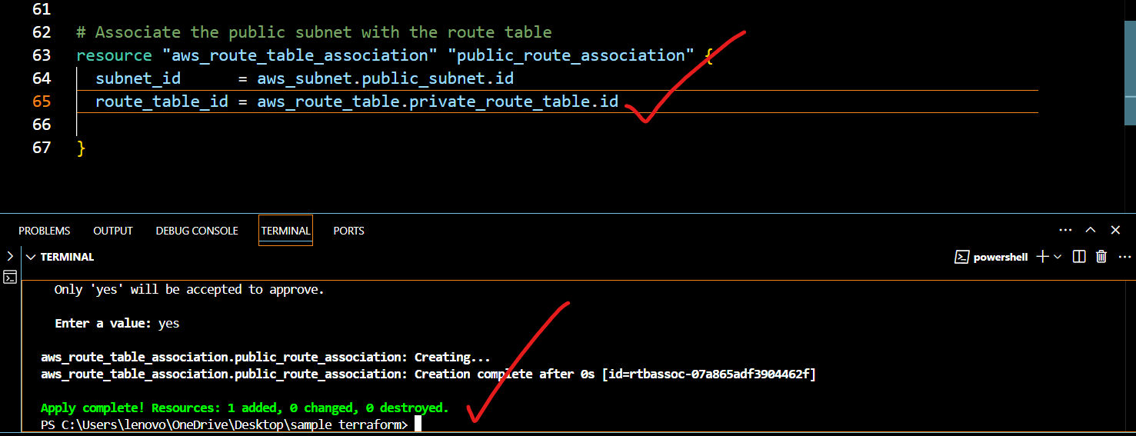

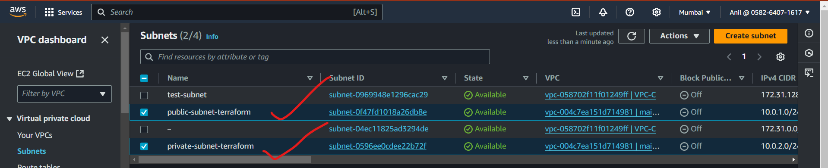

**5) Associate subnet with Route Table**

# Associate the public subnet with the route table

resource "aws_route_table_association" "public_route_association" {

  subnet_id      = aws_subnet.public_subnet.id

  route_table_id = aws_route_table.private_route_table.id

}

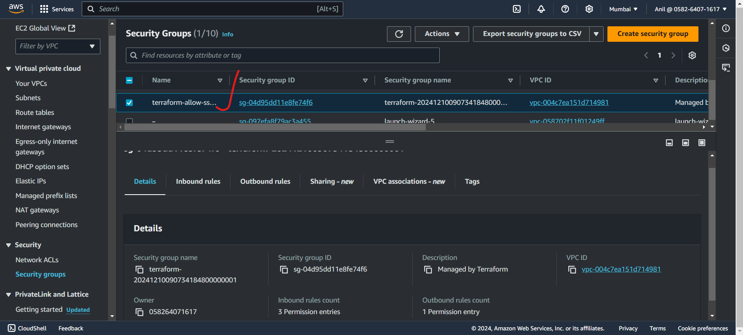

**6) Create Security Group to allow port 22.80,443**

# Create a Security Group for allowing inbound traffic on ports 22, 80, and 443

resource "aws_security_group" "allow_http_https_ssh" {

  vpc_id = aws_vpc.main.id  # Attach this SG to the VPC

  # Inbound rules: Allow traffic on ports 22 (SSH), 80 (HTTP), and 443 (HTTPS)

  ingress {

    from_port   = 22

    to_port     = 22

    protocol    = "tcp"

    cidr_blocks = ["0.0.0.0/0"]  # Allow SSH from anywhere (can be restricted)

  }

  ingress {

    from_port   = 80

    to_port     = 80

    protocol    = "tcp"

    cidr_blocks = ["0.0.0.0/0"]  # Allow HTTP from anywhere

  }

  ingress {

    from_port   = 443

    to_port     = 443

    protocol    = "tcp"

    cidr_blocks = ["0.0.0.0/0"]  # Allow HTTPS from anywhere

  }

  # Optional: Outbound rules (default is allow all traffic)

  egress {

    from_port   = 0

    to_port     = 0

    protocol    = "-1"  # Allow all outbound traffic

    cidr_blocks = ["0.0.0.0/0"]

  }

  tags = {

    Name = "terraform-allow-ssh-http-https"

  }

**7) Create a network interface with an ip in the subnet that was created in step 4**

resource "aws_instance" "tf_instance" {

  ami                    = "ami-053b12d3152c0cc71"  # Update this with the correct AMI ID for your region

  instance_type          = "t2.micro"

  key_name               = "example"

  subnet_id              = aws_subnet.public_subnet.id  # Use the public subnet for internet access

  vpc_security_group_ids = [aws_security_group.allow_http_https_ssh.id]  # Use the security group ID here

  associate_public_ip_address = true

  user_data = <<-EOF

        #!/bin/bash

        sudo apt update -y

        sudo apt install -y apache2

        sudo systemctl start apache2

        sudo systemctl enable apache2

        echo "created apache2 server" > /var/www/html/index.html

  EOF

  tags = {

    Name = "tf_instance"

  }

}

**8) Assign an elastic IP to the network interface created in step 7   
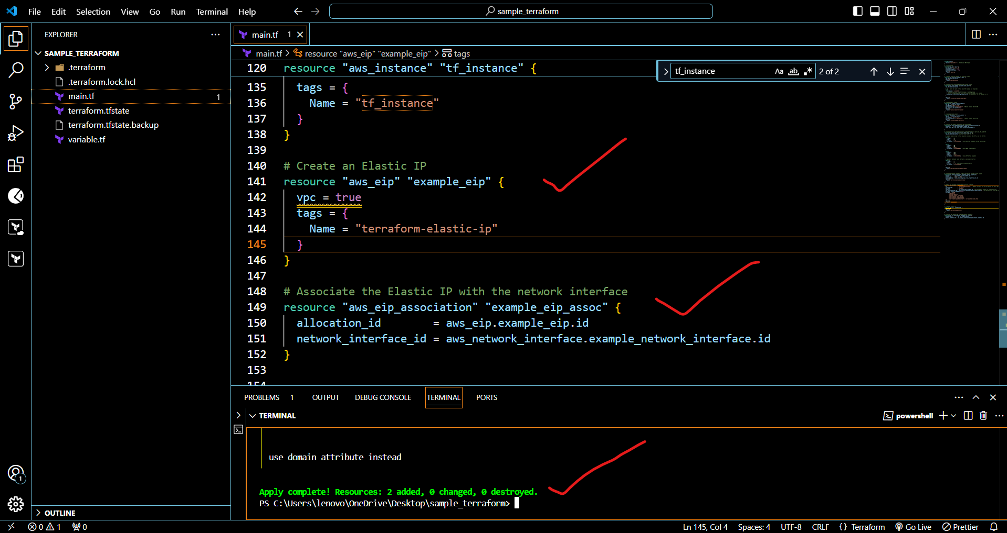  
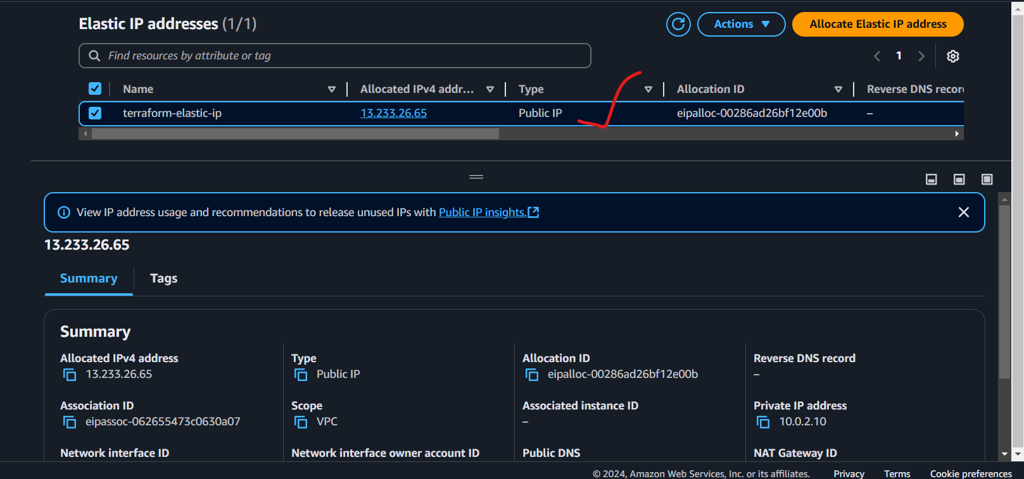  
9) Create Ubuntu server and install/enable apache2  
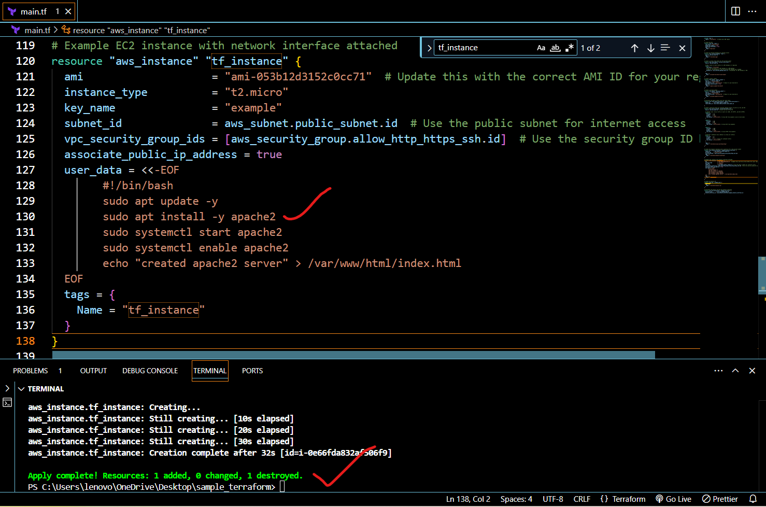**

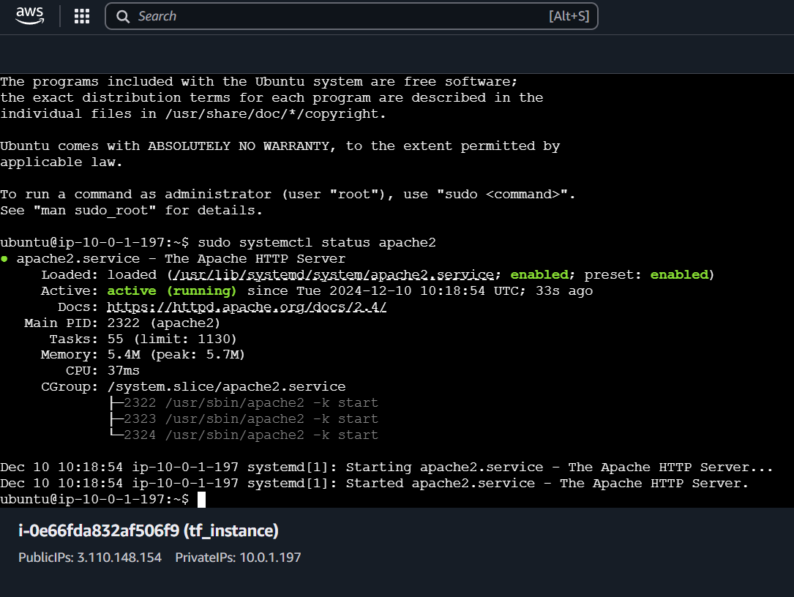

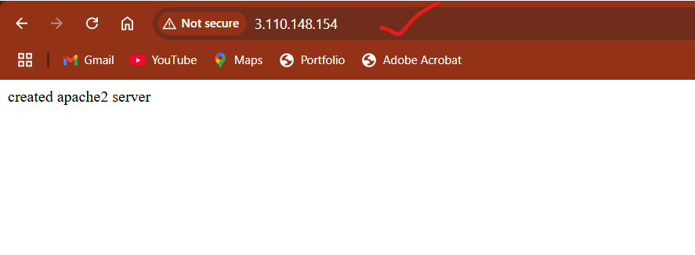

**Configure s3 as backend and dynamo db locking for multi user execution.  
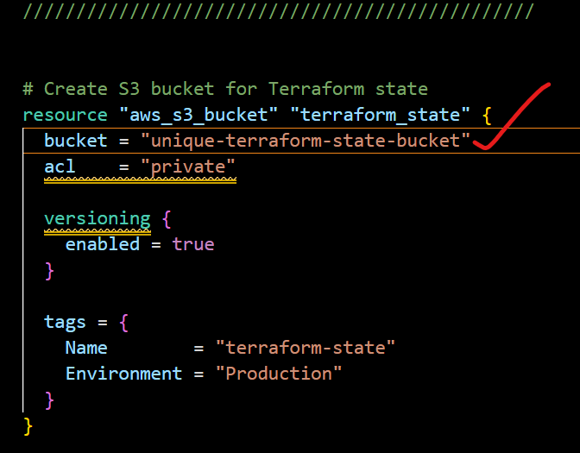  
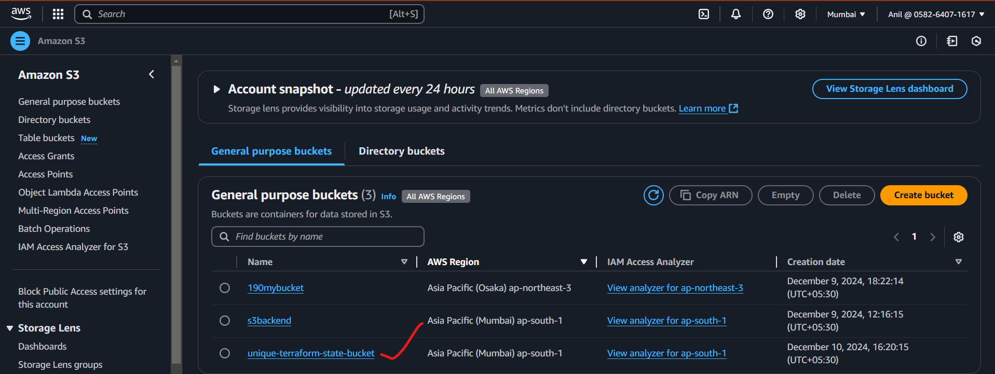**

Dynamodb  
